**FA ⬄ RG ⬄ RE**

I. RG => FA

Construct the FA that corresponds to the following grammar:

S-> ɛ |aA | bB

A-> aA | bB

B -> a | b | c

REVISION:

Q = N ∪ {K}

Σ = Σ

A -> aA

d(A, a) = A

B -> a

D(B, a) = K

F = {S | if S -> ɛ ϵ P} ∪ {K}

SOLUTION TO PROBLEM:

Q = {S, A, B, K}

ɛ = {a, b, c}

F = {K, S}

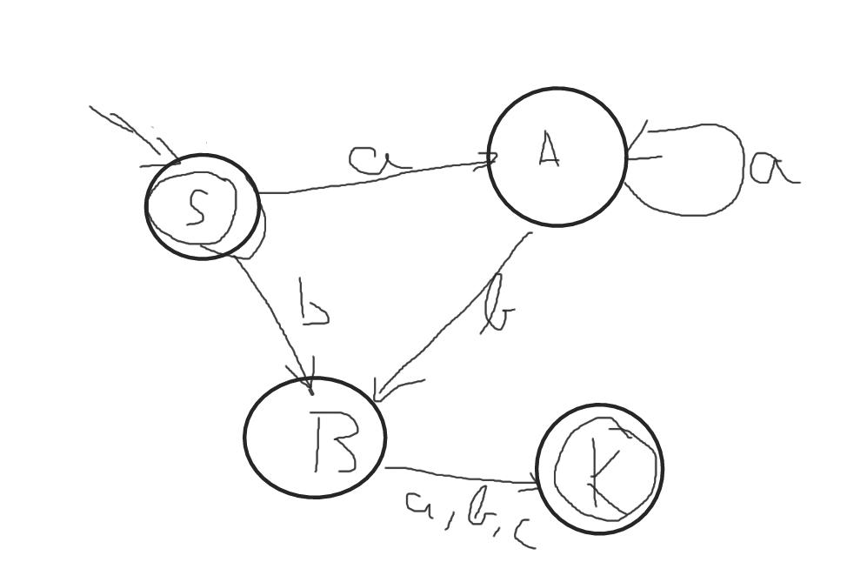

2. Given the regular grammar:

G = ({S,A}, {a,b}, P, S)

P: S -> ɛ | aA

A -> aA | bA | a | b

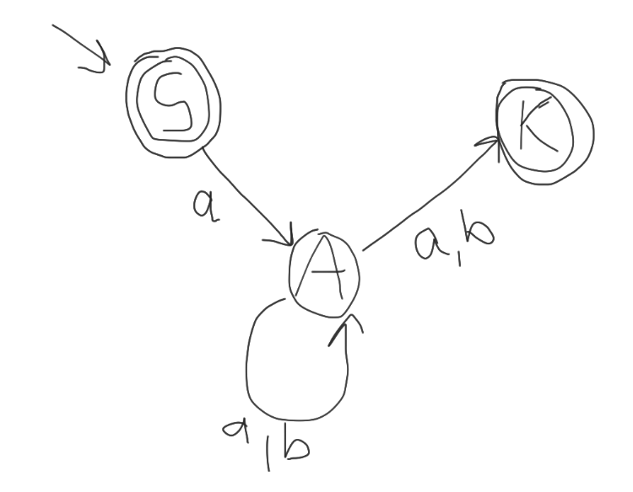

***Remark:*** Always when adding K, add it as a final state

II. FA -> RG

N = Q

Σ = Σ

S = q0

3. Given the following FA construct the equivalent right linear grammar.

Q = {p ,q, r}

q0 = p

F = {r}

Σ = {0, 1}

|  |  |  |
| --- | --- | --- |
| d | 0 | 1 |
| p | q | p |
| q | r | p |
| r | r | r |

N = {A, B, C}

Σ = {0, 1}

P: A -> 0B | 1A

B -> 1A | 0C | 0

C -> 0C | 0 | 1C | 1

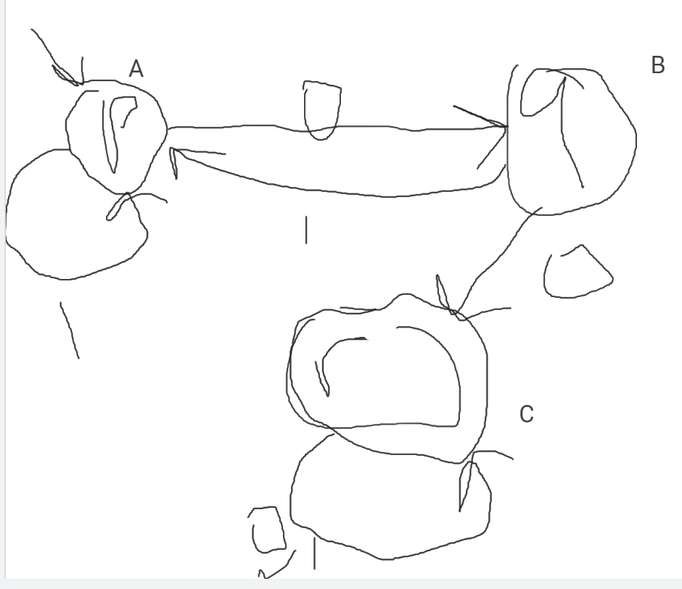

4.

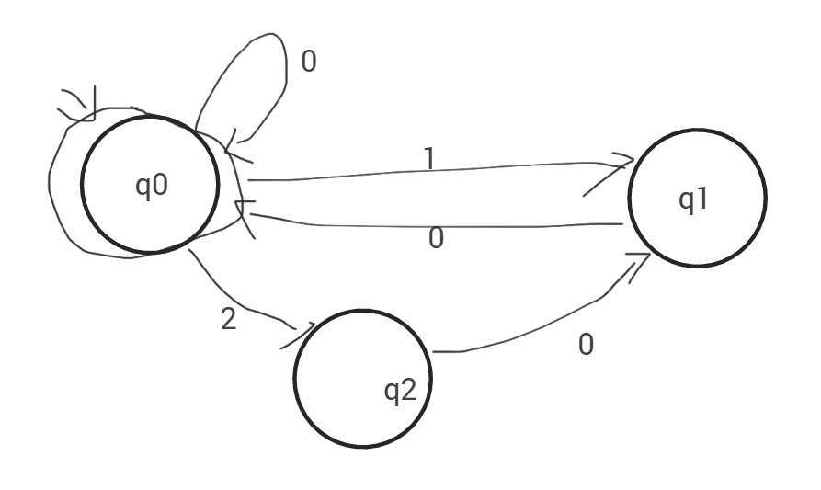

Determine the grammar given the photo above:

N = {q0,q1,q2}

T = {0, 1,2}

P: q0 -> 0 | 1q1 | 2q2 | 0q0 | ɛ

q1 -> 0q0 | 0

q2 -> 0q1 | 0

III. RG => RE

5. G = ({S,A,B}, {0,1}, P, S}

P: S -> 0A | 1B | ɛ

A -> 0B | 1A

B -> 0S | 1

In order to find the RE we build the system of equation.

**The RE wil be the solution corresponding to S.**

**⬄ ⬄**

A = 1A + 0B is in the normal form => A = 1*0B

We substitute A in (3): B = 001*0B + 01B + 0 + 1 ⬄ B = (001*0 + 01)B + 0 + 1 in the normal form => B = (001*0 + 01)* + (0 + 1)

Now we compute A: A = 1*0(001*0 + 01)* + (0 + 1)

S = 01*0(001*0 + 01)* + (0 + 1) + 1(001*0 + 01)* + (0 + 1) + ɛ

6. Given the G=({P,Q,R},{0,1},P – set of productions,P – starting symbol)

G=({P,Q,R},{0,1},P,P)

P: P -> 0Q | 1P

Q -> 0R | 1P

R -> 0R| 1R | 0

⬄

In (3) if we apply the property of distributivity of RE:

R = (0+1)R + 0 => R = (0 + 1)*0;

We replace R in (2): Q = 0(0 + 1)*0 + 1P

Replace Q in (1): P = 0(0(0 + 1)*0 + 1P) + 1P ⬄ P = 00(0 + 1)*0 + 01P)+ 1P ⬄

P = 00(0 + 1)*0 + (01 + 1)P ⬄ P = (01 + 1)*00(0+1) *0

$$\left\{\begin{aligned}P=0Q+1P (1) \\ Q=OR+1P (2) \\ R=0R+1R+0 (3)\end{aligned}\right.$$